**-EVEREST ENGINEERING COLLEGE**

*(Affiliated to Pokhara University)*

**Sanepa-2, Lalitpur**



**A MAJOR PROJECT MID REPORT ON**

**“SMART LAB MANAGEMENT SYSTEM”**

**SUBMITTED BY**

**Prejeena Karmacharya [20120041]**

**Rashik Joshi [20120043]**

**Samir Aryal [20120050]**

**Sandesh Gwachha [20120051]**

**SUBMITTED TO**

**Department of Computer and IT Engineering**

**Everest Engineering College**

**Sanepa, Lalitpur**

**JUNE,2024**

# 

# ABSTRACT

The Smart Lab System project aims to assist teachers in monitoring student performance through interactive visualization techniques and evaluating the condition of Lab computers using a rule-based expert system. This system simplifies the process for teachers by providing an easy way to track students' overall performance and identify any issues with Lab computers, whether hardware. With this system, teachers can effortlessly assess both student progress and the operational status of Lab computers.

In the existing system, Lab sessions are managed manually on paper, making it difficult to evaluate each student's performance and the condition of the Lab computer. In the proposed system, all data is stored in a secure and easily retrievable database. This allows teachers to effortlessly access student performance data and monitor the status of Lab computers at any time. By streamlining these processes, the Smart Lab System enhances the efficiency and effectiveness of managing Lab sessions.

**ABSTRACT 2**

**CHAPTER1: INTRODUCTION 5**

1.1 BACKGROUND 5

1.2 Problem Statement 5

1.3Aim and Objectives 6

Aim 6

Objective: 6

1.4 Project Features 6

1.5 Feasibility Analysis 7

1.5.1 Economic Feasibility 7

1.5.2 Technical feasibility 7

1.5.3 Time feasibility 7

1.5.4 Operational Feasibility 7

**CHAPTER 2: LITERATURE REVIEW 8**

**CHAPTER 3: METHODOLOGY 11**

3.1 Data Collection Method: 11

3.2Data Analysis Method: 11

3.3 Teacher’s Insights on Attendance Taking: 12

3.4 Expert System on finding out the need of maintenance for computers: 12

3.5: System Requirement 12

3.5.1 Software Requirement 12

5.5.2 Hardware Requirement 13

**CHAPTER 4: DFD DIAGRAM 13**

4.1: 0-LEVEL DFD 13

4.2: 1-LEVEL DFD: 14

4.3: 2-LEVEL DFD: 15

**CHAPTER 5 : ER DIAGRAM: 17**

**CHAPTER 6: USE CASE DIAGRAM: 18**

**CHAPTER 7: REFERENCES 19**

CHAPTER1: INTRODUCTION

## 1.1 BACKGROUND

Smart Lab system has a bunch of benefits from various points of view. The Smart Lab System is a Management Information System (MIS) designed to make it easier for teachers to manage Lab sessions. In the old system, everything was done on paper, which made it hard to keep track of student performance and the condition of Lab computers.

With the Smart Lab System, all data is stored in a secure database that teachers can access anytime. Teachers can take attendance, monitor student performance, and check Lab assignments easily. Based on attendance and how well students complete their tasks, teachers can give grades as per the performance of a student . This system makes it simple for teachers to see how students are doing and to assign grades fairly and efficiently.

## 1.2 Problem Statement

In the traditional Lab system, teachers have to evaluate each student's attendance, Lab assignments, and performance on paper. This makes it difficult and time-consuming to analyze student progress. Additionally, teachers must manually check if the computers THAT students are using are working properly. This process can interrupt and delay Lab sessions.

Tracking student progress with a paper-based system is hard, leading to slow and ineffective evaluations. This makes it challenging for teachers to manage Lab sessions effectively and ensure all equipment is functioning correctly. The Smart Lab System aims to solve these problems by simplifying these processes with a digital solution.

## 1.3Aim and Objectives

## Aim

* The main aim of Smart Lab Management System is to digitize the manual paperwork for teachers, making attendance tracking and student’s performance visualization easier and Lab computer management convenient with the use of an expert system.

## 

## Objective:

* To make taking attendance quick, easy, and accurate, ensuring that teachers can efficiently record student presence and lateness within a set time frame.
* To detect and report any problems with Lab computers automatically, providing teachers with detailed information about which computer is in need of maintenance.

## 

## 1.4 Project Features

* Digital Attendance Tracking: Easily record and manage student attendance online.
* Visual Student Progress Tracking: Monitor student performance visually for better analysis.
* Automatic Computer Condition Checks: Use an expert system to detect and report issues related to main internal components of Lab computers automatically.
* Accessible Data Storage: Store all student and computer data securely in an easily accessible database.
* Minimized Disruptions: Quickly identify and address computer problems to minimize interruptions during Lab sessions.

## 1.5 Feasibility Analysis

In the following ways our project is feasible

## 1.5.1 Economic Feasibility

“Smart Lab Management System” is a major project prepared by four group members. In this project minimum cost is assumed as it is done based on our ideas and online resources. If any customer wants to buy the project the price is very affordable and minimum.

## 1.5.2 Technical feasibility

This system is compatible with every smartphone and pc as it is built using PHP, MySQL, JavaScript, Python.

## 

## 1.5.3 Time feasibility

The proposed system aims to reduce the time and effort required by teachers. The paper-based system is complicated and makes it difficult to evaluate students. It is also challenging to determine which computers are functioning properly during Lab sessions. With our project, these tasks become simpler, making it feasible and practical.

## 1.5.4 Operational Feasibility

“Smart Lab management system” is easy to operate and has an effective response. This system doesn’t require any expert to handle as this is simple and can be understood by anyone.

# 

# CHAPTER 2: LITERATURE REVIEW

[1]Traditionally, hardware defect detection has relied on dedicated hardware mechanisms. These approaches, while effective, often incur significant cost due to the need for additional hardware components. Furthermore, they lack flexibility as modifications to testing strategies typically require physical hardware alterations.This approach leverages the concept of "Access Control Extension" (ACE) instructions, granting software the ability to access and manipulate the internal state of the microprocessor. By utilizing existing scan chain infrastructure, the proposed technique achieves efficient testing while minimizing hardware overhead

[2]The facial recognition-based attendance management system is designed to automate and streamline attendance recording in educational institutions, removing the inefficiencies of existing manual techniques. The system comprises four phases: dataset construction, face detection, face recognition, and attendance updates. Initially, numerous photos of each student are collected using a camera, pre-processed to identify the Region of Interest (ROI), scaled, transformed to grayscale, and saved as a Labeled dataset. The system detects human faces using OpenCV's Haar-Cascade classifier, with the detectMultiScale module maximizing detection accuracy using parameters such as scaleFactor and minNeighbors. For face recognition, the Local Binary Pattern Histogram (LBPH) method creates histograms from training data and compares them to real-time video input for accuracy. Recognized faces are indicated as existing on an Excel sheet

[3]K. P. Mohamed Basheer, C. V. Raghu proposes a fingerprint attendance system that uses biometric technologies to automate an educational institution's attendance process. This provides a foolproof technique of marking attendance and will save time that would otherwise be spent calling names. Without the teacher's help, a hand-held device is utilized to record attendance. During the lecture, students can record their attendance and pass the gadget. To signify their attendance in class, students would be required to place their finger on the sensor.

[4]The review by Abdalkarim and Akgün (2022) discusses the evolution and implementation of automated attendance tracking systems across various domains, highlighting key technologies and methodologies. Traditional attendance methods are often time-consuming and prone to errors, leading to the development of automated systems utilizing biometric recognition, QR codes, GPS, and mobile devices. Biometric systems, such as fingerprint and face recognition, offer high accuracy but can be resource-intensive. QR code and barcode systems provide a simpler alternative but may be susceptible to manipulation. The integration of mobile technologies and cloud computing further enhances the efficiency and accessibility of these systems, making them more adaptable to modern educational and organizational needs​​.

[5]This annotated bibliography focuses on the research paper "Design and Evaluation of Hybrid Fault-Detection Systems" by Reis et al. and explores the concept of combining hardware and software techniques for fault-detection in processors. This paper proposes CRAFT, a suite of hybrid fault-detection techniques that combine hardware and software methods to achieve better reliability, performance, and cost trade-offs compared to purely hardware or software-based approaches. The authors introduce Mean Work To Failure (MWTF) as a new metric to evaluate fault-detection systems and propose a new framework for reliability assessment.

[6]This research proposes a system (MAMS) that uses students' phones to track attendance in mobile learning environments. MAMS is faster and easier than paper attendance sheets, freeing up teachers' time and offering valuable data for managing student participation. The researchers tested MAMS with computer science students and likely discussed how well it worked, including any challenges. This study suggests that mobile technology could be a useful tool for attendance and understanding student engagement in mobile learning.

[7]Student attendance monitoring in universities traditionally relies on manual methods, prone to errors and inefficiency. This paper by [authors] (2024) proposes an NFC-based system with biometric verification (fingerprints) to address these limitations. Inspired by existing research on NFC for attendance, the authors present a pilot project at BME with successful results, paving the way for secure and reliable attendance monitoring.

# CHAPTER 3: METHODOLOGY

## 

## 

## 3.1 Data Collection Method:

The first step for the data collection method for Smart Lab Management System included surveys, interviews with teachers and administrators, observation of Lab activities, and analysis of existing documentation such as attendance registers and Lab reports. Additionally, data on computer conditions is collected through system monitoring tools, manual logging of parameters like storage occupancy, CPU temperature, RAM usage, GPU usage, and software crash reports. The timestamp feature, where attendance must be marked within a 10-minute window, was specifically evaluated through these surveys. This feature ensures that students arriving late are automatically marked absent or late, encouraging accurate attendance tracking. Our data offers the comprehensive perspective of a digitized Lab attendance system which not only simplifies tracking students progress but also facilitates monitoring the condition of the computers.

## 3.2Data Analysis Method:

After collecting the data, we analyzed the students' Lab attendance records and their Lab reports. We also examined teachers' perspectives on the attendance-taking process and how they monitor Lab performance and Lab reports of particular students. Recommendations included digitizing attendance with the SLMS timestamp feature, standardizing Lab report evaluation criteria, and implementing an expert system for proactive equipment maintenance. Additionally, we gathered data on the usage and performance of Lab computers and other equipment where we analyzed necessary features like software crash reports, CPU temperatures etc. that could be added for the effectiveness of computer conditions included in Smart Lab Management System. This comprehensive analysis provided insights into the effectiveness of current practices and areas for improvement in Lab attendance management and progress tracking of students' performance.

## 

## 3.3 Teacher’s Insights on Attendance Taking:

Our analysis of teacher’s insights on attendance taking revealed that many teachers found it possible to take Lab attendance and mark students as present up to a maximum of 25 minutes into the Lab session. This survey provided a broader view on what to include in the timestamp feature. The extended window allowed for a more flexible approach to attendance, accommodating delays without compromising the accuracy of attendance records. Additionally, some teachers also evaluated Lab performances and reviewed Lab reports. This approach not only streamlined the attendance process but also provided insights into students' progress, enhancing the overall efficiency of Lab management. The survey from teachers highlighted the practicality of this approach, suggesting various features to be modified to improve and enhance the system.

## 

## 3.4 Expert System on finding out the need of maintenance for computers:

Our Lab has experienced frequent computer problems (e.g., slow performance, crashes) in the past as well as in present time that disrupt Lab sessions and cause frustration for students. To address this, we propose building an expert system that monitors key system metrics (CPU usage, RAM usage, disk space, CPU temperature) and software crash reports. By analyzing this data in conjunction with usage patterns, the expert system will be programmed with decision-making rules (based on industry standards and our Lab's specific needs) to identify computers requiring maintenance before they disrupt Lab sessions. This will allow us to schedule maintenance proactively, minimizing downtime and ensuring smooth Lab operations.

## 

## 

## 3.5: System Requirement

## 3.5.1 Software Requirement

* **Front End:** JavaScript
* **Back End:** PHP
* **Database:** MySQL
* **Expert-System:** Python

## 5.5.2 Hardware Requirement

* General PC
* Smart phone

# 

# 

# CHAPTER 4: DFD DIAGRAM

## 4.1: 0-LEVEL DFD

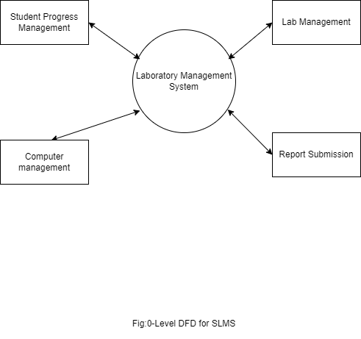

## 

## 4.2: 1-LEVEL DFD:

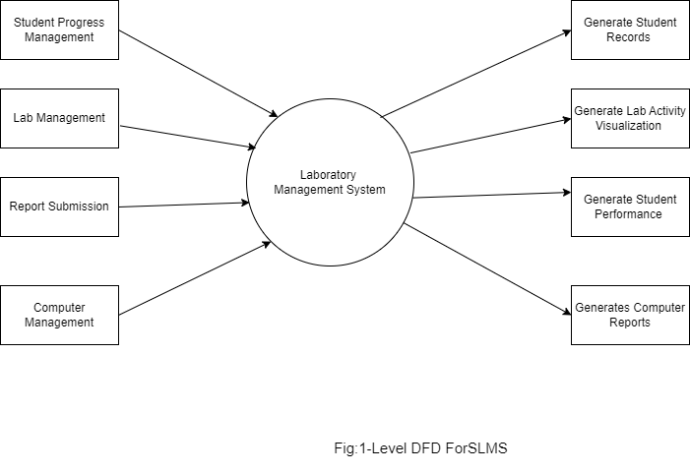

## 4.3: 2-LEVEL DFD:

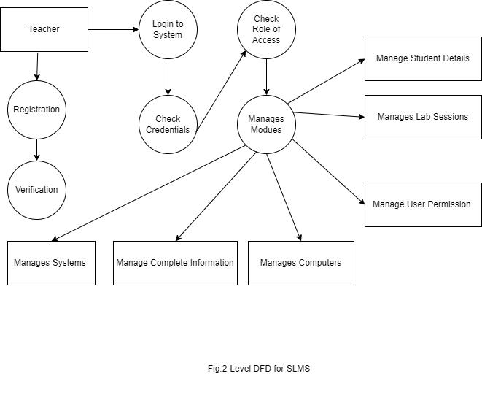

# 

# 

# CHAPTER 5 : ER DIAGRAM:

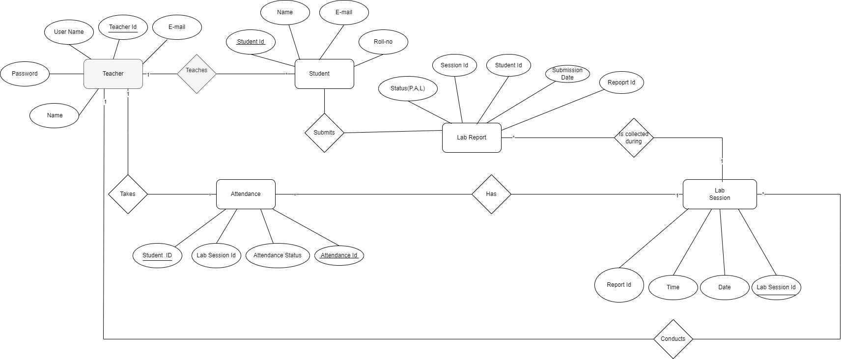

# CHAPTER 6: USE CASE DIAGRAM:

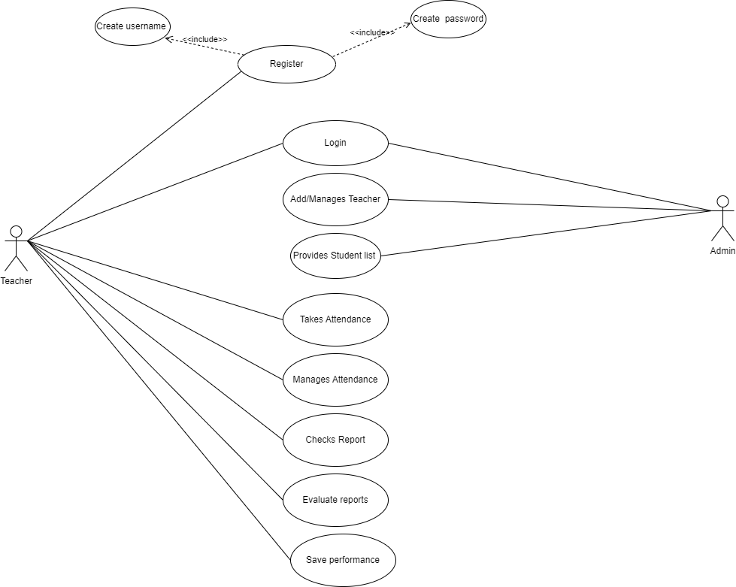

# CHAPTER 7:ACTIVITY DIAGRAM

# CHAPTER 8:FLOW CHART

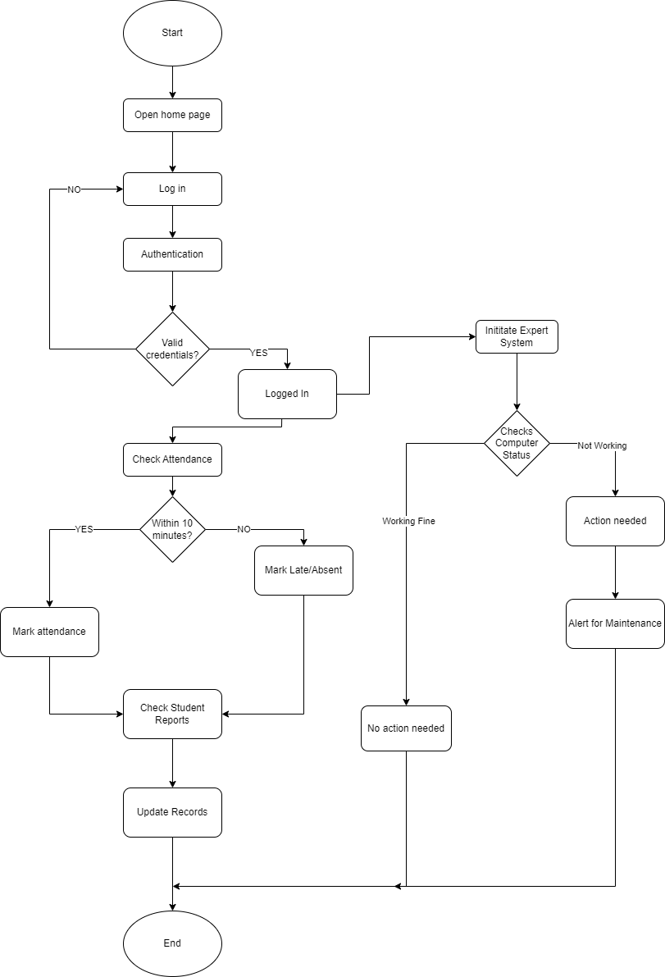

# CHAPTER 9:SEQUENCE DIAGRAM

# CHAPTER 7: REFERENCES

|  |  |
| --- | --- |
| [1] | **Kypros Constantinides, Onur Mutlu, Todd Austin, Valeria, Bertacco. Software-Based Online Detection of Hardware Defects** |
| [2] | **P. S. H. A. Smitha, "Face Recognition based Attendance Management System," vol. 9, no. 07,may-2020, 2020.** |
| [3] | **K. M. B. a. C. Raghu, "Fingerprint attendance system for classroom need," no. 2013, 2012.** |
| [4] | **Abdalkarim, B. A., & Akgün, D. (July 20-23,2022)** |
| [5] | **Reis, G. A., Chang, J., Vachharajani, N., Rangan, R., August, D. I., & Mukherjee, S. S. (2007, June). Design and Evaluation of Hybrid Fault-Detection Systems. In Proceedings of the 34th Annual International Symposium on Computer Architecture (ISCA '07) (pp. 17-26). ACM.** |
| [6] | **Lewandowski, J., & Arochena, H. E. (2011). Mobile attendance and time monitoring system for m-learning applications: Design and pilot results. In Proceedings of the IADIS International Conference on Mobile Learning (pp. 1-10).** |
| [7] | **Benyó, B., Sodor, B., Doktor, T., & Fordos, G. (Year). *Student attendance monitoring at the university using NFC*. Budapest University of Technology and Economics, Department of Control Engineering and Information Technology, Magyar Tudsok krt. 2, H-1117 Budapest, Hungary.** |